Q1)

Ans : -

Some of the main features of HTML 5 are as follows

1. Improved Multimedia Support - HTML 5 allows for integrating multimedia elements such as <audio> and <video> directly into web pages without the need for plugins like Flash.

2.Canvas Element - HTML5 introduced the <canvas> element,allowing dynamic,interactive graphics to be created and manipulated within a web page.

3.Geolocation API - is an API for obtaining the users location,enabling web applications to offer location-based services.

Example : Get the users current location.

4.Local Storage - HTML 5 introduced the local storage API, which allows for the storage of data on the users device,improving performances and reducing the need for round - trips to the server.

5.New Structural Elements - HTML 5 introduced new semantic elements such as <header>,<footer>,<nav>, and <article>, etc that make it easier to structure and organize content on web page.

6.Form Implementation -HTML 5 introduced several form improvements to forms,including new input types like,date,time and color,as well as new attributes such as required & autofocus.

7.Accessibility improvements - HTML 5 provides better support for accessibility,including the ability to provide alternative text for images & improved support for screen readers.

2Q)

Ans : -

HTML Entities: HTML entities are special codes that represent reserved characters, symbols, or characters with specific meanings in HTML. They are used to display characters that might otherwise be interpreted as HTML code or cause rendering issues in web browsers. HTML entities are written using an ampersand (&) followed by a specific code or name, and ending with a semicolon (;)

5 Commonly Used HTML Entities: < - Represents the less-than symbol <. Example:
This is an example <em>text</em>.
> - Represents the greater-than symbol >. Example:
For more information, visit our website > here.
& - Represents the ampersand symbol &. Example:
For further details, contact us & we'll assist you.
" - Represents a double quotation mark " Example:
The title of the book is "The Great Gatsby".
© - Represents the copyright symbol ©. Example:
© 2023 ACME Corporation. All rights reserved.

3Q)

Ans : -

Accessibility in Web Development: Accessibility in web development refers to designing and coding websites in a way that ensures people with disabilities can perceive, understand, navigate, and interact with digital content effectively. It involves making web content inclusive and usable for everyone, regardless of their abilities.

Importance of Accessible Websites:

Inclusivity: Accessible websites ensure that everyone, including people with disabilities, can access and use online information and services.

legal Compliance: Many countries have laws requiring websites to be accessible, avoiding legal issues and promoting equal access.

User Experience: Accessible design often leads to improved user experiences for everyone, including clear navigation and content structure.

Business Growth: Accessible websites reach a wider audience, increasing engagement, loyalty, and potential customer base.

Benefits for User Groups :

visual Impairments: Accessibility provides screen reader support and text alternatives, aiding blind and visually impaired users.
Hearing Impairments: Captions and transcripts benefit those with hearing impairments by making audio content understandable.

Motor Disabilities: Keyboard navigation and easy-to-click elements assist users with motor limitations.

Cognitive Disabilities: Accessible design simplifies content and layout, aiding individuals with cognitive challenges.

Elderly Users: Accessible websites accommodate age-related limitations, ensuring usability for elderly users
.
Mobile Users: Accessible design improves mobile experiences through simplified and responsive layouts.

4Q)

Ans : -

Use Semantic HTML Elements : Using semantic HTML elements helps improve accessibility by providing meaningful structure to your content. Semantic elements like <header> ,<nav> ,<main> ,<article> , and convey the purpose of different sections to assistive technologies, making it easier for users with disabilities to navigate and understand the content.

Provide Alt Text for Images: Adding descriptive alt text to images using the alt attribute ensures that users who cannot see the images can understand their content and purpose. Screen readers read aloud the alt text, making visual content accessible to people with visual impairments. Aim to make alt text concise, informative, and relevant to the image.

Use Color with Care: Color plays an important role in web design, but it should not be the only means of conveying information. Ensure that color is not the sole indicator of meaning. For example, when using error messages, pair color with text that explains the error. Additionally, maintain sufficient color contrast between text and background to enhance readability for users with low vision.

5Q)

Ans : -

<!DOCTYPE html>
<html lang="en">
<head>
<meta charset="UTF-8">
<meta name="viewport" content="width=device-width, initial-scale=1.0">
<title>HTML5 Features Showcase</title>
</head>
<body>
<header>
<h1>HTML5 Features Showcase</h1>
<p>Welcome to our beginner-friendly webpage showcasing HTML5 Features.</p>
</header>

<section>
<h1>Feature 1: Video Playback</h1>
<p>
HTML5 introduced the <code>&lt;video&gt;<code> element for code embedding videos directly
into web pages.
</p>
<video width="400" controls> <source src="sample-video.mp4" type="video/mp4"/>
</video>
</section>

<section>
<h1>Feature 2: Form Validation</h1>
<p>

HTML5 introduced built-in form Validation , reducing the need for custom JavaScript code.
</p>
<form>
<label for="email">Email:</label>
<input type="email" id="email" name="email" required>

<br/>

<input type="submit" value="Submit">
</form>
</section>

<section>
<h1>Feature 3:Semantic Tags</h1>
<p>
HTML5 introduced semantic tags like <code>&lt;header&gt;</code>
<code>&lt;nav&gt;</code> , <code>&lt;main&gt</code> , and more,which improve page strucure
and accessibility.
</p>
<article>
<h3>Article Title</h3>
<p>
THis is a sample article content.Semantic tags make it easier to strucure your content
improve search engine optimization.
</p>
</article>
</section>

<footer>
<p>Created by Your Name and &Copy ; 2023 </p>
</footer>
</body>
</html>

OUTPUT : -

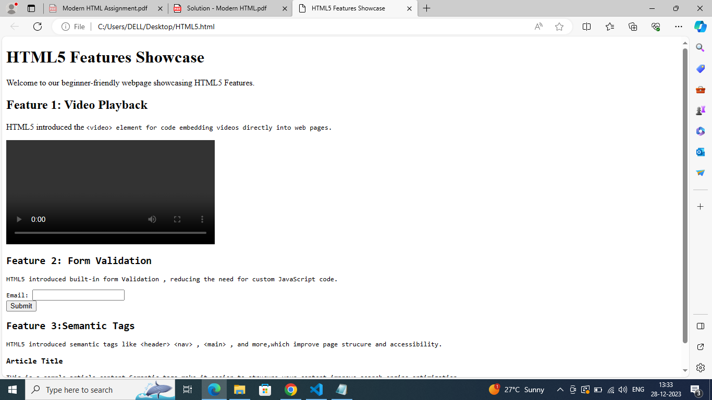

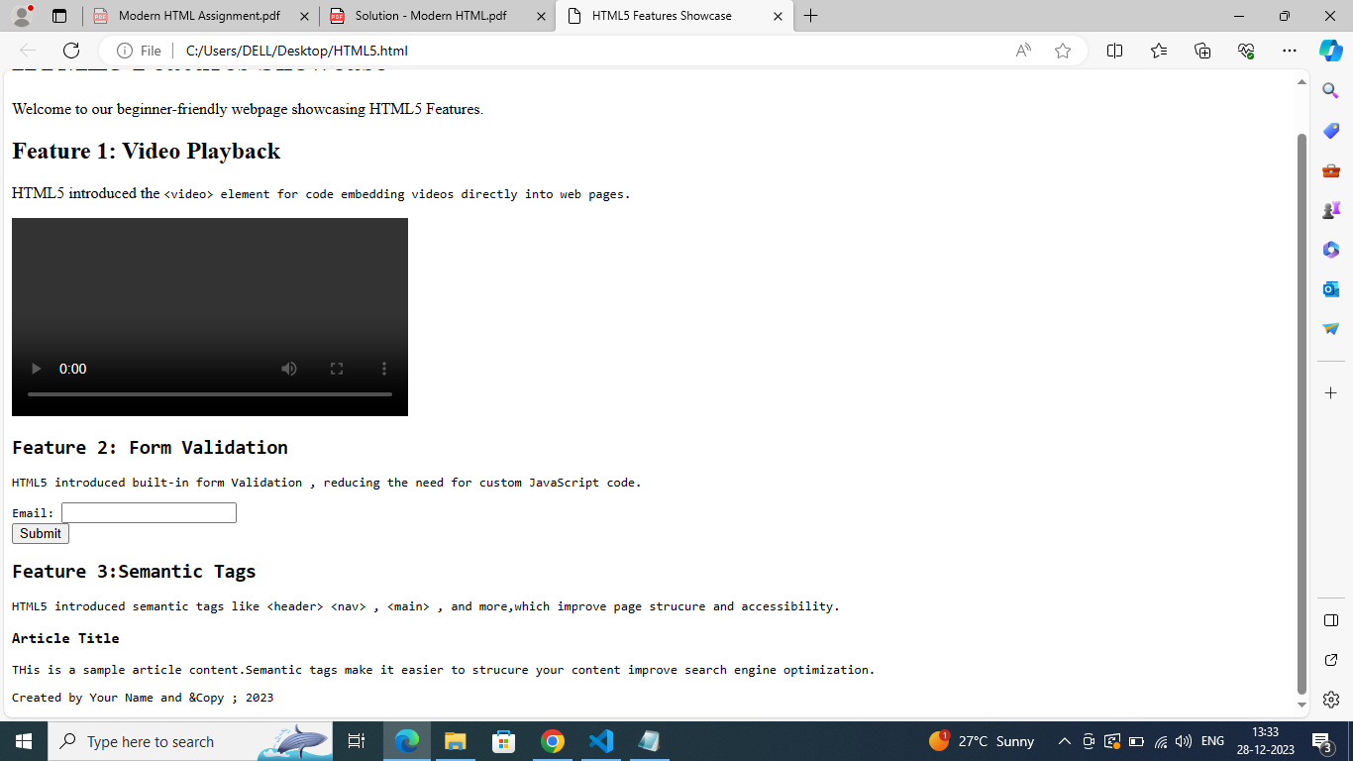

6Q)

Ans : -

<!DOCTYPE html>
<html lang="en">
<head>
<meta charset="UTF-8">
<meta name="viewport" content="width=device-width, initial-scale=1.0">
<title>HTML v/s HTML5</title>
</head>
<body>
<h1>HTML v/s HTML5</h1>
<table border = "1">
<thead>
<tr>
<th>HTML</th>
<th>HTML5</th>
</tr>
</thead>
<tbody>
<tr>
<td>
It reqiures plugins like Adobe Flash to support audio and video content.
</td>
<td>
Provides built-in support for multimedia and element such as video and audio
without the need for a plugin.
</td>
</tr>
<tr>
<td>It has fewer elements when compared to HTML5.</td>
<td>It includes new elements and attributes such as time,date, and color. Required
and autofocus in input types of the tag element as well.
</td>
</tr>
<tr>
<td>It does not have support for local storage.</td>
<td>It has support for loacl storage i.e. local storage.</td>
</tr>
<tr>
<td>Less semantic elements,thereby providing less web accessibility features.</td>
<td>
<p>
It supports more semantic elements,such as &lt;header&gt;,&lt;footer&gt;,
&lt;nav&gt;, and article&gt;,thereby improving accessibility

</p>
</td>
</tr>
</tbody>
</table>
</body>
</html>

OUTPUT : -

